
Project Report
Project Title:
Stormwater Harvesting and Filtering System
Prepared by:
Kundan Singh Shekhawat
Email: kundansingh.shekhawat@students.mq.edu.au
Student ID: 48849855
Date:
06/11/2025

Table of Contents
1 Introduction 6
2 Project Title: 6
2.1 Objectives: 6
3 Description of the Industry Application 6
4 Equipment Used in the PLC Kit 7
4.1 Main Control Components (Electrical and PLC Module) (Vicente, 2024) 7
4.2 Pneumatic Components 8
4.3 Software and Programming Tools 8
5 Project Design Schematic and Description 9
5.1 Inlet and Primary Storage (Tank 01) 9
5.2 Pre-Filtration and Pressure Protection (Tank 02) 9
5.3 UV Filtration and Temperature Control 10
5.4 Treated Water Distribution and Drain Line (Tank 03) 10
6 Ladder Logic Program and HMI 10
6.1 Binary Input Processing Section 11
6.2 Main Process Logic Section 12
6.2.1 Pump Start Logic 12
6.2.2 Pump Stop Logic 12
6.2.3 Valve 1 Open Logic 13
6.2.4 Valve 1 Close Logic 13
6.2.5 Maintenance Indicator Logic 14
6.2.6 Valve 2 Closing Condition 14
6.2.7 Valve 2 Opening Condition 14
6.2.8 Normal UV Operation 15
6.2.9 UV Over-Temperature Protection 15
6.2.10 Secondary Protection and Cooling Activation 15
6.2.11 Normal Operation of Valve 3 and Valve 4 (Valve 3 Open / Valve 4 Closed) 16
6.2.12 Valve 3 Closed / Valve 4 Open 16
6.2.13 Pump and UV Self-Test Routine 16
6.3 HMI Design and Functionality (Myles, 2020) 17
6.3.1 System Overview Screen 17
6.3.2 Process Control Screen 18
7 Project Operation 19
7.1 Innovative Input Design (Binary Combination Logic) 19
8 REFERENCE 22

Table of Figures
Figure 1: Main Control Module 8
Figure 2: Pneumatic Components 8
Figure 3: Piping and Instrumentation Diagram 9
Figure 4: Binary combination of inputs 11
Figure 5: Pump start/stop and Valve1 Open logic 13
Figure 6: Valve 1 Close and Valves Maintenance Indication Logic 14
Figure 7: Valve2 Open/Close and UV filter Logic 15
Figure 8: UV Filter over Heating and Valves 3&4 Open/Close Logic 16
Figure 9: System Test Logic 17
Figure 10: System Overview Screen 18
Figure 11: Process Control Screeen 19

Table of Tables
Table 1: Push Button Representation 20
Table 2: Binary Inputs for PLC 21
Table 3: PLC I/O Port 21

Introduction
This stormwater harvesting system can be used to collect, filter, and reuse rainwater. This will help to reduce water wastage and minimise the reliance on groundwater or municipal supply. The rainwater collection can be done from rooftops, streets, and industrial areas. The system has multistage filtration using sedimentation, UV light treatment, and removal of debris or small solid particles using different filters. This filtered water can be reused for non-potable applications like irrigation, washing, or to recharge groundwater levels.
This system can help mitigate flooding in urban areas, minimise surface runoff, and contribute to better water resource management. It plays a major role in fighting climate issues, sustainability problems mostly in cities and industrial areas (Roman et al., 2017).
In this project, we have created a simplified version of the actual stormwater collection and treatment plant. Our project focuses on PLC-based control logic to provide plant operation, safety, maintenance, and testing logics. The report has detailed process design, P&ID diagram, control sequence, and PLC programming logic.

Project Title:
PLC-Based Control System of a Storm Water Harvesting (SWH) Plant

Objectives:
The main objective was to use a PLC controller to replicate any industrial application, and in our case, it’s a stormwater harvesting system. The project's goal is to simulate and automate different stages of storage, filtration, removal of microorganisms, and distribution channels.
Specific objectives include:
- Develop a P&ID diagram of the different subsystems present in the SWH system.
- Design the control logic for all the operations, mechanical, and electrical components present in the system performance.
- Program and test the algorithm on a PLC platform to monitor the communication between the level sensor, the pump, the pressure sensor, the valve and control signals for maintenance.
- Test the system’s performance for a variety of operational conditions and provide evidence of efficiency in managing stormwater.
This project needs you to apply mechatronics and automation principles in a practical situation by integrating mechanical, electrical, and software sides into one system.

Description of the Industry Application
These systems are widely used in newly developed cities, many industries like mining, and commercial buildings. These systems help with the collection of storm water, remove contaminants, and reuse the treated water for non-potable purposes. These systems are widely used in landscape irrigation or plant cooling. Automated stormwater systems play a key role in sustainability and regulatory compliance where water availability is limited (Foo et al., 2017).
These automated systems use a PLC/SCADA for level control, pump protection, and monitoring. Additionally, they safely divert the water to drain when quality or operating conditions are not acceptable.

Equipment Used in the PLC Kit
The PLC training and control kit is based on the Omron Sysmac platform. It has both electrical and pneumatic components. The whole setup provided by the mechatronics lab was used to build the project for programming, testing, and simulation.

Main Control Components (Electrical and PLC Module) (Vicente, 2024)
- Omron NX1P2-9024DT1 PLC: To run all control logic and I/O processing.
- Omron NA5-7W001B-V1 HMI: for operator interaction, system display, and manual control.
- Omron S8VK-S12024 Power Supply: Provides 24VDC control power to all modules.
- Omron W4S1-05D Switch Hub: Enables Ethernet-based communication
- Omron ASSULTRAESAM4QX Router (4G LTE): remote access and monitoring.
- 6 × G2RV-ST700 Relays: for isolating control signals to field devices.
- 4 × Pushbuttons (Green, Yellow, Red, Blue): testing, start/stop, and function selection.
- 4 × Indicator Lamps (Green, Yellow, Red, Blue): for visual indication of system status and alarms.
- Main Power Switch (240VAC): Supplies power.
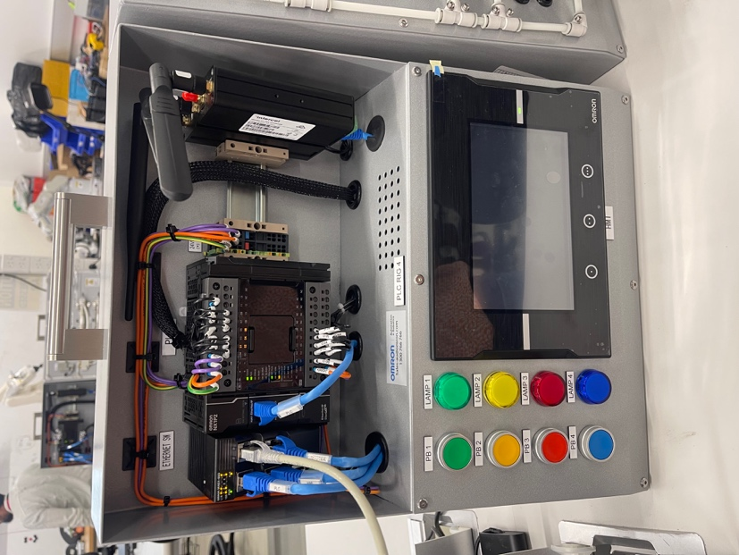
Figure 1: Main Control Module

Pneumatic Components
- 4 × Pneumatic Cylinders: for motion and position sensing.
- 4 × Solenoid Valves: controlling pneumatic flow.
- Air Regulator with Filter: clean and regulated air supply.
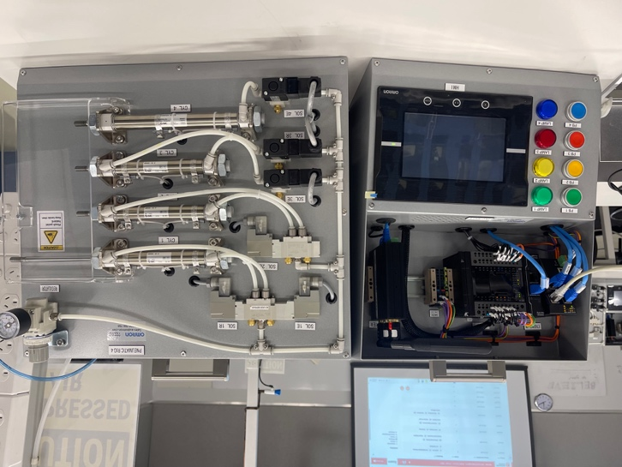
Figure 2: Pneumatic Components

Software and Programming Tools
- Omron Sysmac Studio: IDE used for programming the PLC and designing the HMI user interface.

Project Design Schematic and Description
The Piping and Instrumentation Diagram (P&ID) (see Figure 3) shows all the component-level sensors, the number of water storage tanks, the pressure sensor used in filtration tanks, UV filter with real real-time temperature monitor system for the Storm Water Harvesting.
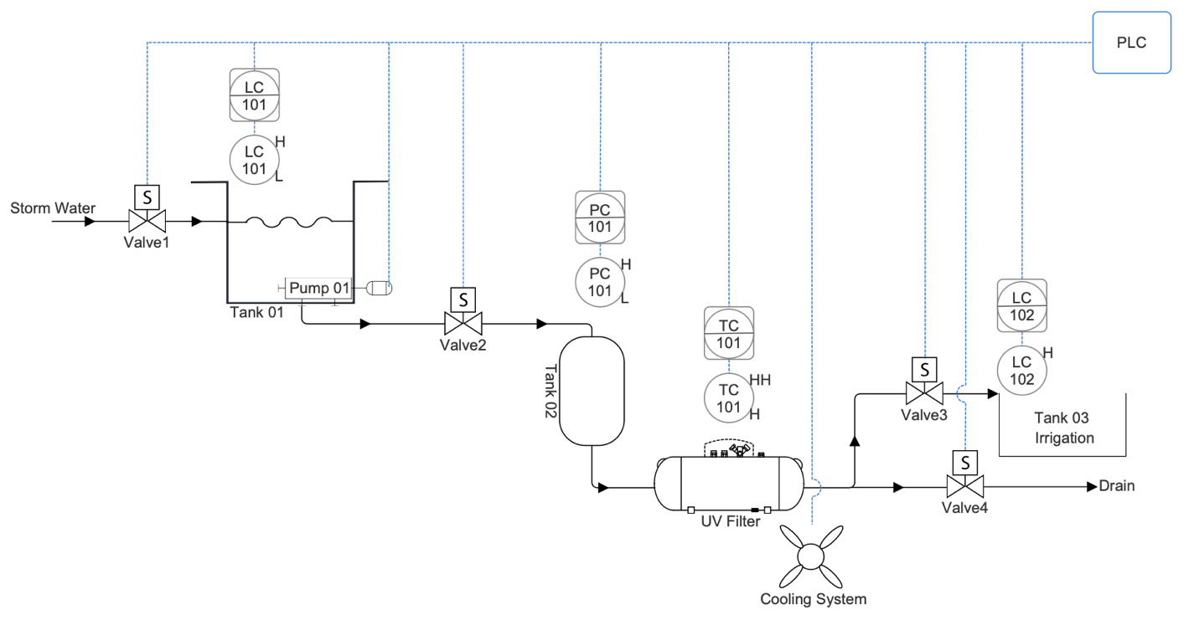
Figure 3: Piping and Instrumentation Diagram

Inlet and Primary Storage (Tank 01)
Stormwater enters Tank 1 through Valve 1, and this valve manages the supply to the tank by opening and closing using inputs from the level sensor in the tank.
- LC101 checks the water level in the tank using two level sensors at high (H) and low (L) water levels.
- When water is low in the tank, it will trigger the low water level sensor, and it will open valve 1 so that water can start filling the tank and if at that time the pump is running, then it will stop the pump operation.
- Valves will close if the water level reaches the high-water level sensor.

Pre-Filtration and Pressure Protection (Tank 02)
To send the water from tank 1 to tank 2, we need to turn the pump on using a manual switch. Valve 2 controls the water flow into tank 2. Valve 2 takes instructions from a pressure sensor placed inside Tank 2. Tank 2 can be considered as the first filtration stage, as here we remove solid particles from the water using different sizes of filters.
- A Pressure Controller PC101 checks the difference in pressure in tank 2 inlet and outlet.
- If the pressure goes above the safety limit, then valve 2 will be closed, and it will stop the pump to prevent more water supply on the way to tank 2 via valve 2.
- Valve 2 opens again as soon as pressure is in the range of operation, and it will turn on the pump again automatically.
This setup protects the filtration system from blockage or physical damage.

UV Filtration and Temperature Control
The filtered water from tank 2 flows into a UV filtration unit. Here, the UV filter will remove the live microorganisms and disinfect the water by ultraviolet irradiation.
- The Temperature Controller TC101 monitors the UV lights temperature:
- The PLC has been instructed to turn off the UV lamp if the temperature is above the high limit (H).
- A cooling system will turn on if, for some reason, the UV lamp temperature continues to rise above the HH limit. Also, the UV lamp will remain turned off until the system reaches normal operating temperature.
This two-step protection logic stops the on-off cycling of the UV lamp and extends its life.

Treated Water Distribution and Drain Line (Tank 03)
The final stage is to determine if water will go through valve 3 for irrigation or go through valve 4 to drain. Both valve 3 and 4 work opposite to each other, which means the system will automatically close one valve and open another:
- The PLC will open valve 3 and close valve 4 if the UV lamp is active or the water level in Tank 03 (LC102) is not high. In this case, water will be used for irrigation purposes.
- The PLC will open valve 4 and close valve 3 if the UV lamp is not active or the water level in Tank 03 (LC102) is high. In this case, supply will drain.
Only one discharge valve (Valve 3 or Valve 4) can remain open to prevent backflow and ensure safe water management.

Ladder Logic Program and HMI
We used Omron Sysmac Studio to make the PLC program for the Storm Water Harvesting (SWH) system. The complete program has two main sub-programs:
- Binary Input Processing Section: This code uses the ON/OFF status of the four pushbuttons into binary combinations to use as multiple virtual input conditions.
- Main Process Logic Section: The actual control logic of the process uses input signals from binary inputs. It has logic for valve control, pump operation, pressure, temperature sensor, level sensor, and the final discharge logic.
Additionally, we designed an HMI using the Omron NA5 panel. It provides a user-friendly environment for operators to monitor process status. Operators can view alarms and perform manual pump control, keep an eye on maintenance requirements or system testing to check if all the subsystems are working correctly or not (Bolton, 2011).

Binary Input Processing Section
As shown in Figure 4 each rung shows one binary combination that can be performed using the four push buttons (PB1–PB4).
Each combination can trigger a true condition for a global variable. These global variables are used in the main process logic for different sensors and operations.
We observed a practical issue during the testing that it was hard to press two or more pushbuttons exactly at the same time. Since we cannot manage the delay between button presses, a Timer ON Delay (TON) function block was used for each input. This TON helped us provide the right input each time.
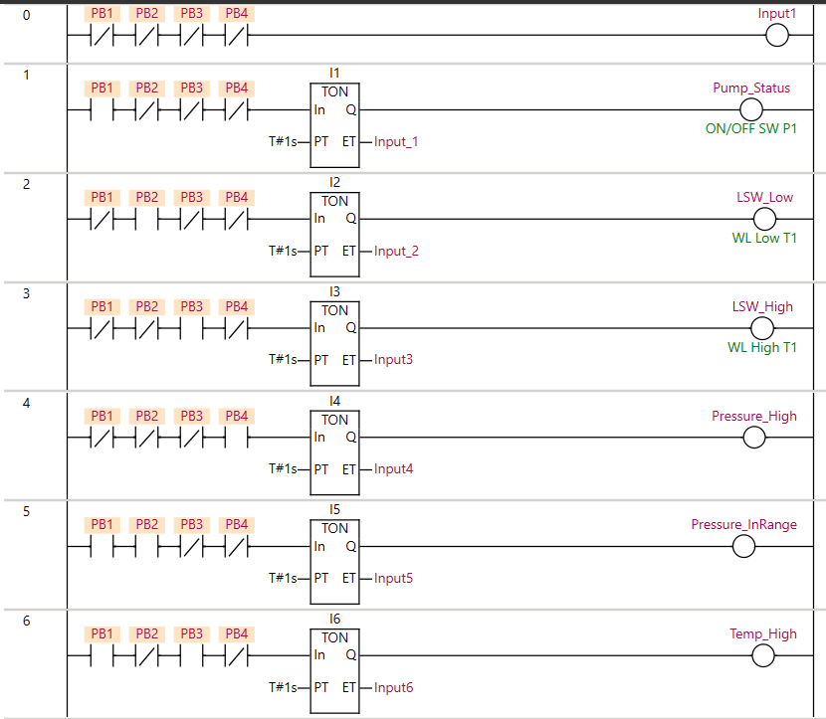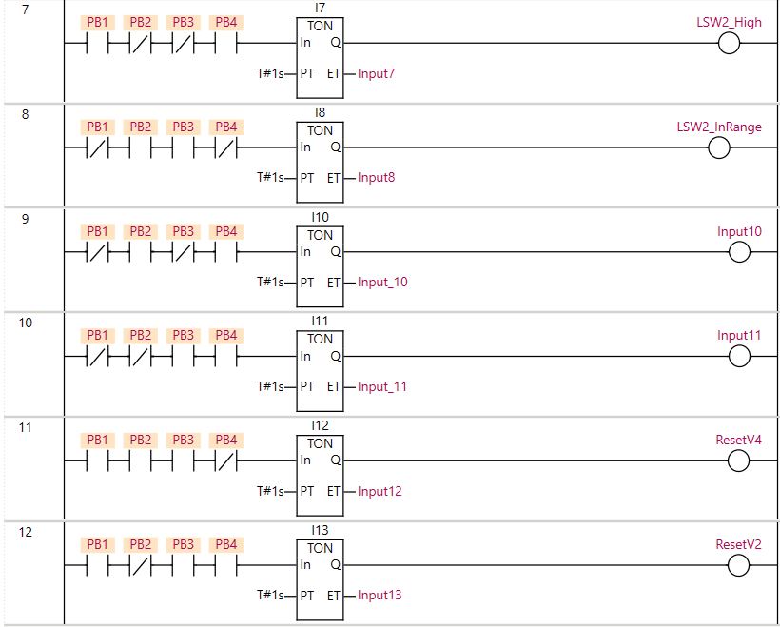
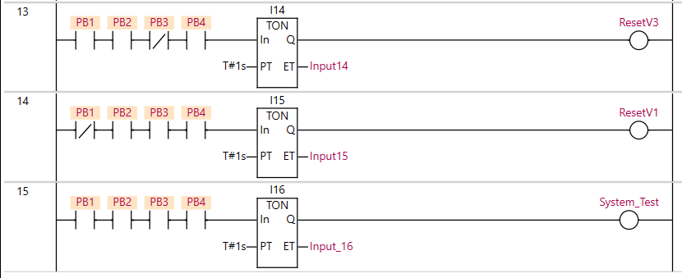
Figure 4: Binary combination of inputs

Main Process Logic Section
The first stage of the ladder program controls the pump, which moves water from Tank 01 to Tank 02.

Pump Start Logic
In rung 0, the program will wait for the pump start command. When PB1 is pressed for the first time and there is no other fault condition or test mode is active, it will set the Pump_status. The lamp energises after a 2-second delay time, showing that the pump is running and water is flowing through valve 1 to tank 1.
We are storing the status of Pump_status in a memory bit so that when we press it again, both Pump_status and the memory bits are in their true condition. With this logic, PB1 will act as a toggle button for the pump.

Pump Stop Logic
Rungs 1, 2 and 8 are responsible for the stop logic for the pump. They handle manual and automatic shutdown conditions.
- In Rung 2, when you press PB1 again and LAMP1(pump) is already ON, it will reset the memory bit, and this will turn off the pump after a 2-second delay (On_delay_pump_SB).
- The one delay in rung 2 helps so that no one stops the pump accidentally just by pressing the PB1.
- In Rung 8, the pump is stopped automatically:
    - Tank 01 Level Low (LSW_Low) is active, showing water level is low in tank 1.
    - Tank 02 Pressure High (Pressure_High) is active, showing that the filter in tank 2 needs cleaning or replacement, and water cannot pass through properly, creating a pressure difference at the inlet and outlet of tank 2. This will trigger a stop sequence for pump and close valve 2.
These logics will trigger the pump_trip condition and it will trun off the pump in tank 1.
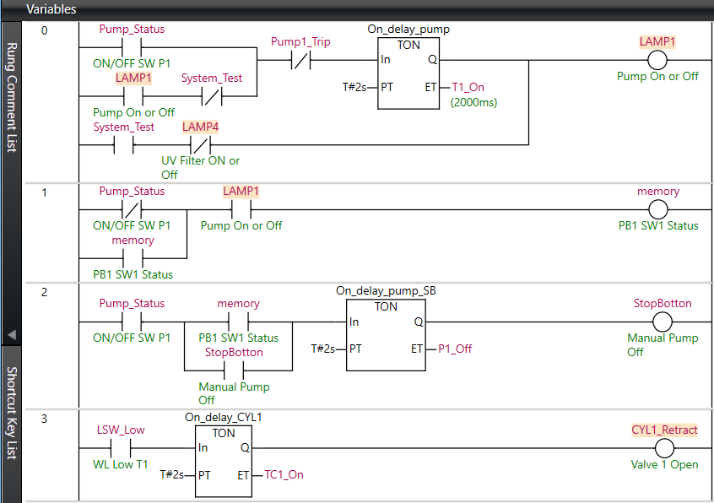
Figure 5: Pump start/stop and Valve1 Open logic

Valve 1 Open Logic
In Rung 3, when there is no or very little water, it will trigger the low-level switch (LSW Low) in tank 1, and the PLC will initiate the valve 1 opening command. We used a Timer ON Delay (TON) of 2 seconds so that the opening signal is only true if the low-level condition remains low for more than 2 seconds. This delay will stop any false triggering due to moving water surface or noise in the level sensor. Once the timer (On_delay_CYL1) ends, it will retract CYL1 to open valve 1.

Valve 1 Close Logic
In Rung 5, when the water level is high, it will trigger the high-level switch (LSW High), showing that tank 01 has reached its capacity, and the PLC will close valve 1. We used a timer OFF Delay (off_delay_valve1) to hold the valve in the closed state for a short time, even if the level signal suggests that the water level is not high anymore. Because of this, logic valve 1 will remain in the closed position until the level actually goes below the highest point to prevent frequent opening and closing cycles.
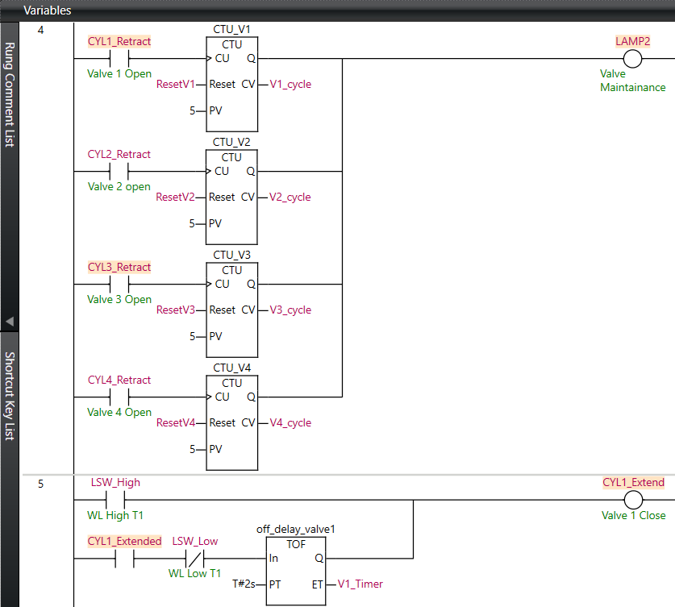
Figure 6: Valve 1 Close and Valve Maintenance Indication Logic

Maintenance Indicator Logic
In Rung 4, a valve maintenance system is used to track the operation cycles of all four control valves (Valve 1 – Valve 4). Each valve increments its counter every time the valve completes an open–close cycle. When the counter for any valve reaches five cycles (PV = 5), it will trigger lamp2 as a maintenance warning. When the lamp is on, it tells the operator that one or more valves need maintenance and require inspection.

Valve 2 Closing Condition
Logic in rung 6 is responsible for the pressure monitor in tank 2, and if the pressure goes above a certain limit, it will set the pressure high condition as true. The PLC will close valve 2 as an output. Once triggered, it puts valve 2 in the closed position and turns off the pump. A TOF block makes sure that the valve remains in a closed condition for a short period even after the pressure is in normal condition. This will prevent unnecessary opening and closing of the valve due to short-term pressure changes. This also shows that filters in tank 2 require attention from the maintenance team.

Valve 2 Opening Condition
In Rung 7, once the pressure returns to normal, it will open the valve as soon as the off delay timer is completed. This will resume the water supply in tank 2 from tank 1.
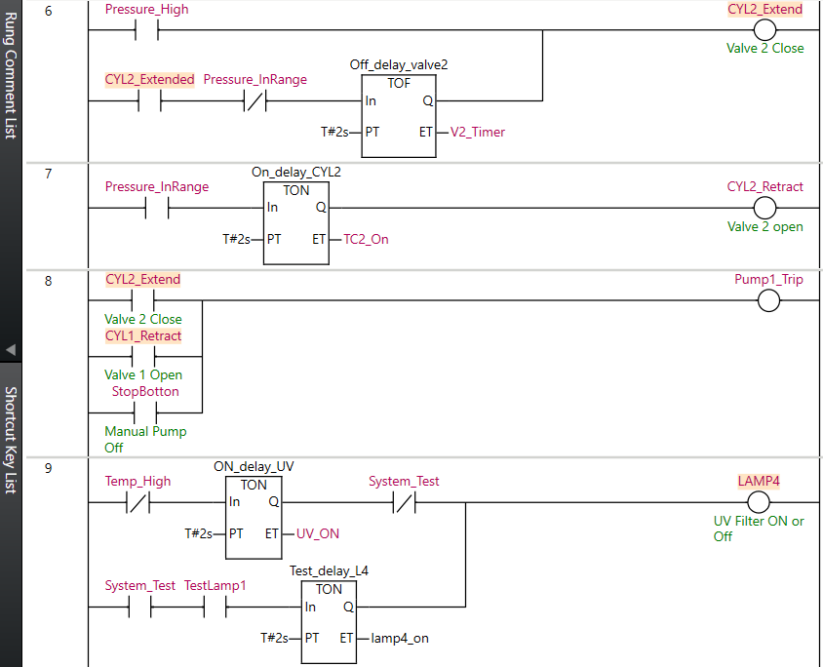
Figure 7: Valve2 Open/Close and UV filter Logic

Normal UV Operation
The UV filter will remain on in normal conditions and keep treating the water. The PLC logic will keep it going until there is a high temperature condition on for the UV lamp.

UV Over-Temperature Protection
In Rung 9, the operating temperature of the UV chamber is monitored using a temperature sensor. When the temperature hits the higher limit PLC will turn on the over-temperature signal, and it will turn off the UV lamp to prevent overheating. When the temperature goes back to a safe range, the UV lamp will turn on again.

Secondary Protection and Cooling Activation
In Rung 13, another level of more complex protection is used to turn off the UV lamp and to turn on the cooling system (LAMP3). If UV temperature rises again in a short period of time, the PLC will trigger a critical overheating condition.
When this occurs:
- The UV system remains off (cannot restart), and
- The cooling system (Cooling_ON) turns on to reduce the chamber temperature.
A Timer OFF Delay (TOF) will keep the cooling system in operation for a defined time to ensure the temperature is stabilised before the system can turn on the UV lamp.
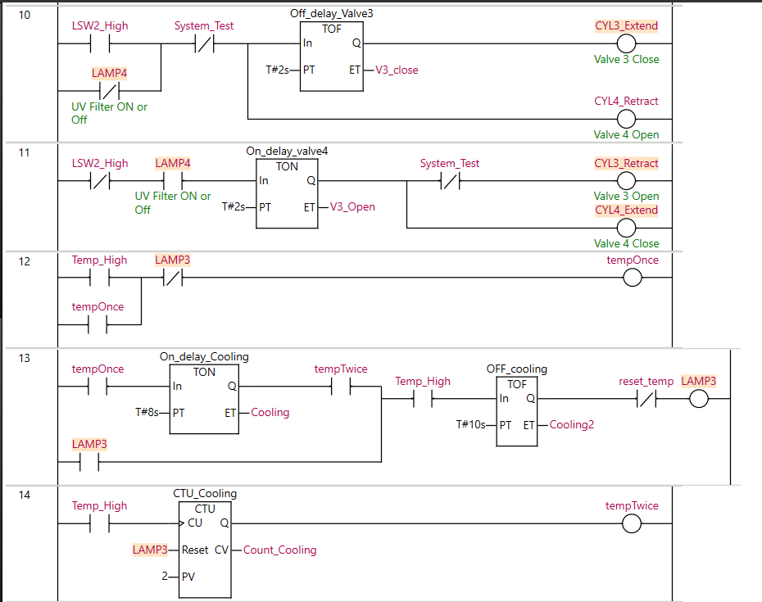
Figure 8: UV Filter over Heating and Valves 3&4 Open/Close Logic

Normal Operation of Valve 3 and Valve 4 (Valve 3 Open / Valve 4 Closed)
In Rung 11, it shows that if UV lamp is on and the reading on the level sensor in the tank is not high, then the system will open valve 3 (CYL3 Retract) and close valve 4 (CYL4 Extend) so that water can go into the irrigation storage tank. We used an interlock, which ensures that both valves cannot be in the same position at the same time to prevent backflow between the storage and drain lines.

Valve 3 Closed / Valve 4 Open
In Rung 10, the PLC will close valve 3 and open valve 4 if the UV lamp is not working or a high level is triggered in tank 3. This will direct the water to drain so that untreated water cannot flow into the storage tanks because the UV filter is not working, or in case of a high level in tank 3, more water will stop going into tank 3 to stop the overflow. We used an on-delay timer (TON) so that the sensor does not trigger any condition because of a false reading.

Pump and UV Self-Test Routine
In Rung 15 and 16, we can use a binary input (System_test) by pressing all four buttons to start the system test cycle. When we activate this mode, the PLC will start testing if all the system components are working or not (in this case, we are only testing the pump and UV lamp)
This logic will first start the pump and then, after a short delay, it will check if the UV lamp is turning on or not. Once both systems turn on, it will be counted using a counter that shows how many components are tested ok, and it will set the test_completed condition as true.
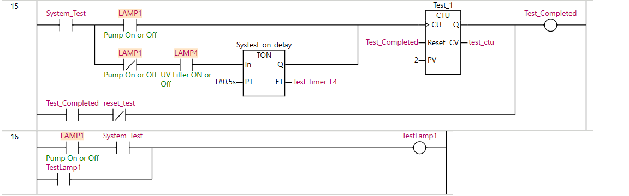
Figure 9: System Test Logic

HMI Design and Functionality (Myles, 2020)
We designed the HMI to give a clear and interactive system for monitoring and controlling the system. The interface has two main display screens, which we developed in Omron NA-Series HMI software:

System Overview Screen
The System Overview screen is our main page (Figure 10) which shows real-time status for all valves, tanks, pumps, sensors, UV filter, and maintenance alerts.
- Tank Status Panels (Tank 1–3):
Tank1 has two indicators to show low or high-water levels. Tank 2 has a high-pressure warning indicator, whereas tank 3 only shows the high-water level on the HMI.
- Temperature Sensors:
This section shows if the UV lamp is on or off, and it also shows if the temperature is within safe operating ranges.
The “Filter Temp” and “UV Light” lamps indicate the current condition of the UV system.
- Valve Operation Section:
Show the real-time position of Valve 1–Valve 4. These lamps are updated by the PLC outputs (CYL1–CYL4) to extend or retract the position.
- Maintenance Indicators:
We have four valve maintenance status boxes for each valve to show how many cycles they have completed and to show the requirement for a maintenance alert. When a valve completes 5 cycles, it will turn on the maintenance lamp.
- Message/Alarm Window:
The alarm window shows the history of alarms. Currently, we have one alarm for the temperature high for the UV lamp, and once we acknowledge it, the logs can be seen in this section.
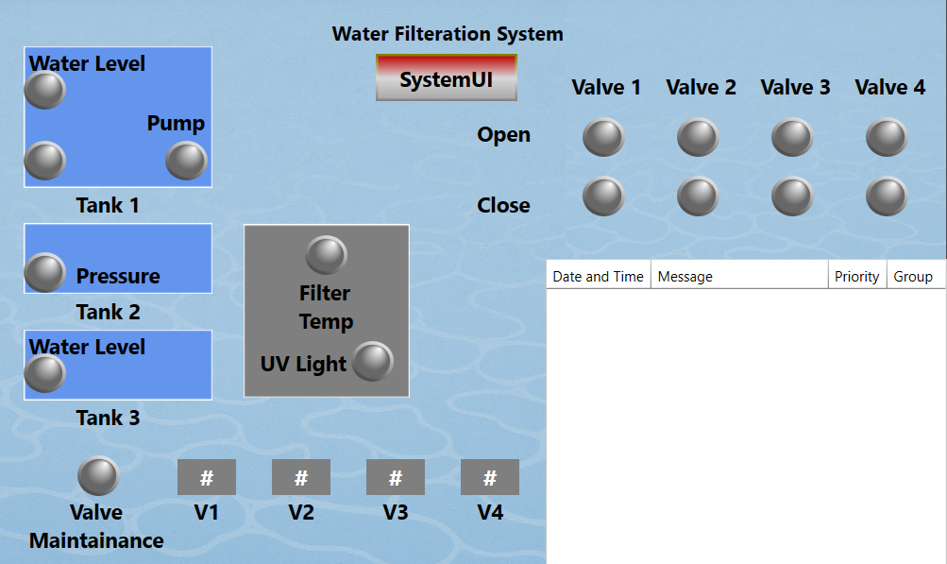
Figure 10: System Overview Screen
This screen can help the operator monitor the entire system for an overview of the filtration and storage process.

Process Control Screen
The Process Control screen (Figure 11) has a more interactive interface where you can monitor the actual process layout with some manual control and system testing indicators.
- Graphical Process Layout:
The interface shows the status of all tanks, valves, the pump, UV filter, and drain line. Each valve (V1–V4) maintenance cycle can be reset individually using dedicated buttons (Reset V1–V4).
- System Test Panel:
The lower left section shows the system test button and an indicator of whether the test is completed or not. The “Test Completed” lamp turns ON if all subsystems pass the test.
- Reset Functions:
The Reset Alarm and Reset Test buttons can be used to acknowledge the warnings and alarms.
- Dynamic Indicators:
When any valve opens or closes, it changes its position and colour to indicate its real-time state. We have an animation in place to show the level in tank 1 and tank 2, pressure in tank 2, the state of the UV lamp and if there is any temperature warning.
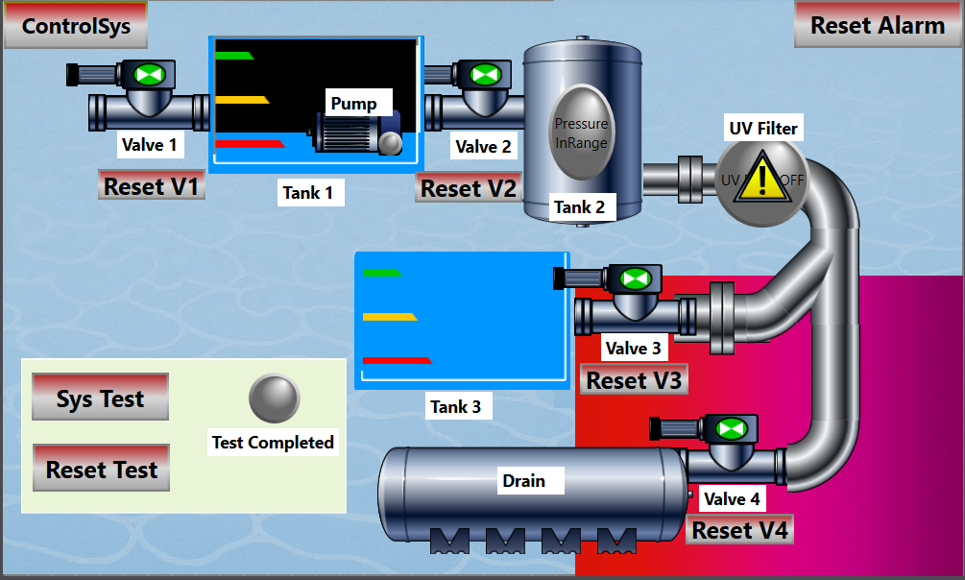
Figure 11: Process Control Screen
This screen provides both manual control and real-time feedback to test, monitor, and adjust the system.

Project Operation
In this section, we will talk about each input and output (I/O) used in the PLC program. This will also provide information about the control logic used in our system.
We used an Omron NX1P2-9024DT1 PLC, which has 4 push buttons, 4 lamps and 4 pneumatic cylinders with a different solenoid valve setup. The cylinders are connected to reed switches to read the current position of the cylinder.

Innovative Input Design (Binary Combination Logic)
Since the available PLC kit provides only four pushbuttons (digital inputs) and our system requires more than four signals (for level, pressure, temperature, and UV status). We used a binary encoding technique to increase the number of virtual inputs.
Each pushbutton represents a binary bit (B3–B0):
Pushbutton | Bit Position | Color | PLC Input Address
PB1 | B0 | Green | I:8
PB2 | B1 | Yellow | I:9
PB3 | B2 | Red | I:10
PB4 | B3 | Blue | I:11
Table 1: Push Button Representation
The system can make up to 16 unique binary codes (0000–1111) by using ON/OFF states of these buttons, and we assigned each code to a specific condition or command.
This design allows the PLC to control multiple sensors using a limited number of physical inputs.
Binary Code | Pushbutton Combination  (B3 B2 B1 B0) | Simulated Input Function | Description in SWH Project
0000 | All OFF | System Idle | Default condition
0001 | Green ON | Pump start/stop button | Start and stop the pump manually
0010 | Yellow ON | Tank 1 Level is Low | Tank 1 level is low -> pump Stop
0100 | Red ON | Tank1 Level is High | Tank1 Level is high -> close valve 2
1000 | Blue ON | Tank 2 Pressure is High | Tank 2 Pressure is High -> Close Valve 2 & stop the pump -> Change the filter.
0011 | Green+Yellow | Tank3 Pressure is in range | The filter is changed, and now the pressure is in range
0101 | Red+Green | Temp of UV system is High | Temp of UV system is High -> stop UV system & close valve 3 & Open Valve 4
1001 | Blue+Green | Tank3 Level is High | Tank 3 Level is High -> close Valve 3 & Open Valve 4
1111 | All ON | System test | Test the pump and UV system -> If okay, show test successful
Table 2: Binary Inputs for PLC
Note: We used these binary combinations in the PLC logic for several instructions. The controller can decode a button's current state into a logical command or instruction.
To control the different sensor conditions, we will use inputs from a reed switch, and we will output to control the solenoid valve and use an indicator lamp to show the action results. The final mapping between the PLC I/O ports and their functions is summarised below.
I/O Ports | Alies | Function in the project
I:0 | Cylinder 1 Retracted | Valve 1 is open
I:1 | Cylinder 1 Extended | Valve 1 is closed
I:2 | Cylinder 2 Retracted | Valve 2 is open
I:3 | Cylinder 2 Extended | Valve 2 is closed
I:4 | Cylinder 3 Retracted | Valve 3 is open
I:5 | Cylinder 3 Extended | Valve 3 is closed
I:6 | Cylinder 4 Retracted | Valve 4 is open
I:7 | Cylinder 4 Extended | Valve 4 is closed
I:8 | Pushbutton Green | B0
I:9 | Pushbutton Yellow | B1
I:10 | Pushbutton Red | B2
I:11 | Pushbutton Blue | B3
O:0 | Cylinder 1 Retract | Open Valve 1
O:1 | Cylinder 1 Extend | Close Valve 1
O:2 | Cylinder 2 Extend | Close Valve 2
O:3 | Cylinder 3 Retract | Open Valve 3
O:4 | Cylinder 3 Extend | Close Valve 3
O:5 | Cylinder 4 Extend | Close Valve 4
O:6 | Lamp1 (green) | Pump start
O:7 | Lamp2 (yellow) | Maintenance needed
O:8 | Lamp3 (red) | UV temperature Fault
O:9 | Lamp4 (blue) | UV start
Table 3: PLC I/O Port

Weekly Project Progress Reflection and Timeline
Week 9: Brainstorming and Concept Finalisation
In the 9th week, we mainly focused on discussing ideas and choosing a realistic industrial project. We looked into a Storm Water Harvesting (SWH) system, but we realised that the real process was too complex for our lab setup. The real system has many different sensors in analogue and digital types. Since the PLC that is available in the lab had limited input and output modules, we had to redesign the project.
To solve this problem, at first, we thought about using one pushbutton for two different functions (for example, pressing it once could mean “tank full,” and pressing it again could mean “tank empty”). But after trying it out, we noticed it might make the logic way too complicated, and we could still get around only eight inputs.
Week 10: Initial Programming and Hardware Test
During week ten, we wrote the first version of the ladder program and tested it on the PLC kit. That’s when we came up with the idea of using four pushbuttons in a binary combination to generate multiple virtual inputs. It worked much better this way, and now we can have up to 16 logical inputs with four physical buttons. While testing, we figured out that it is not possible to press two or more pushbuttons at the same time. We fixed this problem by adding a short delay in logic.
While testing the valves, we found that the four solenoid valves didn’t behave the same. Their reaction times were a bit different. As a result, we had to adjust the timing for each valve in the program.
Week 11: Debugging and Documentation
In week eleven, we ran the full program for the first time. We tested the whole process from water inflow to discharge. A few timing issues showed up, especially when several conditions changed at the same time. We spent most of the time debugging and adjusting the timers (TON/TOF). By the end of the week, the program was running properly, and we started writing the documentation for the PLC logic, P&ID, and design sections.
Week 12: Final Testing and Presentation Preparation
Last week was about final testing and getting ready for the presentation. We designed the HMI screens, which allowed us to see the system status, control the valves, and run test operations visually. After several test runs, the PLC and HMI worked perfectly together.

REFERENCE
Foo, S. W., Mah, D. Y. S., & Ayu, B. E. (2017). Modelling rainwater harvesting for commercial buildings. Water Practice & Technology, 12(3), 698–705. https://doi.org/10.2166/wpt.2017.077
Roman, D., Braga, A., Shetty, N., & Culligan, P. (2017). Design and modelling of an adaptively controlled rainwater harvesting system. Water, 9(12), 974. https://doi.org/10.3390/w9120974
Vicente, R. (2024, April 26). Functional specification of SYSMAC PLC & pneumatic rig for Macquarie University (Document No. MQU0324-FS-140, Rev. 1). Macquarie University.
Bolton, W. (2011). Programmable Logic Controllers. Elsevier.
Myles, C. [Omron Automation]. (2020, October 27). Session #3: HMI programming basics – Sysmac Studio online training [Video]. YouTube. https://www.youtube.com/watch?v=Oek-D60aLfo&t=2319s

APPENDIX
Challenges faced
  - The push button is a momentary input. How can we use it for two inputs, like turning on and turning off the pump?
  - There are only a limited number of inputs. How can we have more than 4 inputs with the current setup?
  - We came up with a binary system to have more than 4 inputs, but the problem was that when you use more than one button as a single input, it can trigger something else accidentally because it is physically hard to push all the required buttons together.
  - With limited knowledge of HMI and very few online videos, it was hard to design an interactive HMI that could show the tank's water level and other indicators.
  - We have many ideas to implement, one of them was to have a maintenance system that can count the number of cycles of all the valves, and once the desired number is reached, it should turn on the maintenance light.
  - We did not have any trouble with cylinders 1 and 4, as they had two inputs of air to close and open the cylinder, so it took us some time to figure out how to work with a cylinder with only one pneumatic input.
Lessons learned
  - We learned about the critical importance of implementing a safety system for every component.
  - We also need preventive maintenance logic so that we can save a lot on unnecessary plant breakdowns.
  - We developed an understanding of working with different types of pneumatic cylinders and solenoid valves and how to use them in our system.
  - It is very important to have a robust PLC program that should not fail in any condition because if it fails, it can cost a lot to the plant, and it might damage the expensive components. The worst case is that it may hurt someone if our program fails to safely terminate a process because of safety issues.
System setup images:
  - All the images used in this report are from our actual setup, and we have prepared a demonstration video that shows the whole setup.
Demonstration Video:
https://drive.google.com/file/d/1L9ESjDdyWR5ueM1aXDrVjSyIeBBjk_IC/view?usp=sharing

